Day 3: Role Prompting Documentation
Prompt I have given to Claude:
You are an AI educator teaching complete beginners. Explain Role-Based Prompting in simple language. Include: * What Role-Based Prompting is * Why it matters when using AI tools like Claude * How assigning a role changes the quality of AI responses * One example without a role prompt * One example with a role prompt * Three practical benefits of Role-Based Prompting Also create a LinkedIn-ready image concept. Image Requirements: * Square LinkedIn post (1080×1080) * Claude-inspired brown, beige and cream colors * Professional and minimal design * Main title: 'Role-Based Prompting' * Add subheading 'ABTalks 60-Day Claude AI Mastery Challenge' * Subtitle: 'Turn Claude into Any Expert You Need' * Show a visual comparison: Without Role Prompt → Generic Answer With Role Prompt → Expert-Level Answer * Include persona cards: Developer Product Manager HR Manager Founder Marketer

Claude responded: Here's your complete Role-Based Prompting lesson, followed by the LinkedIn poster image.
Here's your complete Role-Based Prompting lesson, followed by the LinkedIn poster image.

What is role-based prompting?
It's the practice of telling an AI who to be before asking your question. Instead of just asking "explain this topic," you say "you are a senior software engineer — explain this topic." That one sentence changes everything about the response you get.
Think of it like calling a friend for advice. The same question asked to a doctor, a lawyer, and a financial advisor will get three completely different — and all useful — answers. Role-based prompting lets you pick which expert shows up.
Why it matters with Claude
Claude is trained on vast amounts of knowledge across almost every field. Without a role, it gives you a general, averaged-out answer that's correct but shallow. With a role, it activates a specific lens — vocabulary, assumptions, priorities, and tone all shift to match that expert's perspective.
How a role changes response quality
A role prompt does three things simultaneously: it sets the expertise level (senior vs. beginner), the communication style (technical vs. plain language), and the focus area (what details matter for that role). You're not changing what Claude knows — you're directing how it applies that knowledge.

Without a role prompt:
Prompt: "What should I consider when hiring a new employee?"
Response: "You should look at their skills, experience, and cultural fit. Make sure they can do the job and work well with the team."
Generic. Safe. Not very useful.

With a role prompt:
Prompt: "You are an experienced HR manager at a fast-growing tech startup. What should I consider when hiring a new employee?"
Response: "For a fast-growing startup, prioritize adaptability and ownership mindset over a perfect resume. Look for candidates who've worn multiple hats. Structure your process around a skills test, a values interview, and a reference call focused on how they handle ambiguity. Red flags: people who need heavy process to function, or who haven't shipped anything independently."
Specific. Actionable. Expert-level.

Three practical benefits
First, you get answers calibrated to your actual situation — a developer gets code-first explanations, a founder gets business-impact framing, and an HR manager gets people-process language, all from the same underlying AI.
Second, it saves time on follow-up. A good role prompt eliminates the back-and-forth of "but explain it more simply" or "give me a more technical answer" — you set the register upfront.
Third, it makes you a better prompt writer overall. Learning to describe a role precisely teaches you to think clearly about what expertise you actually need, which is a skill that transfers to real-world communication too.
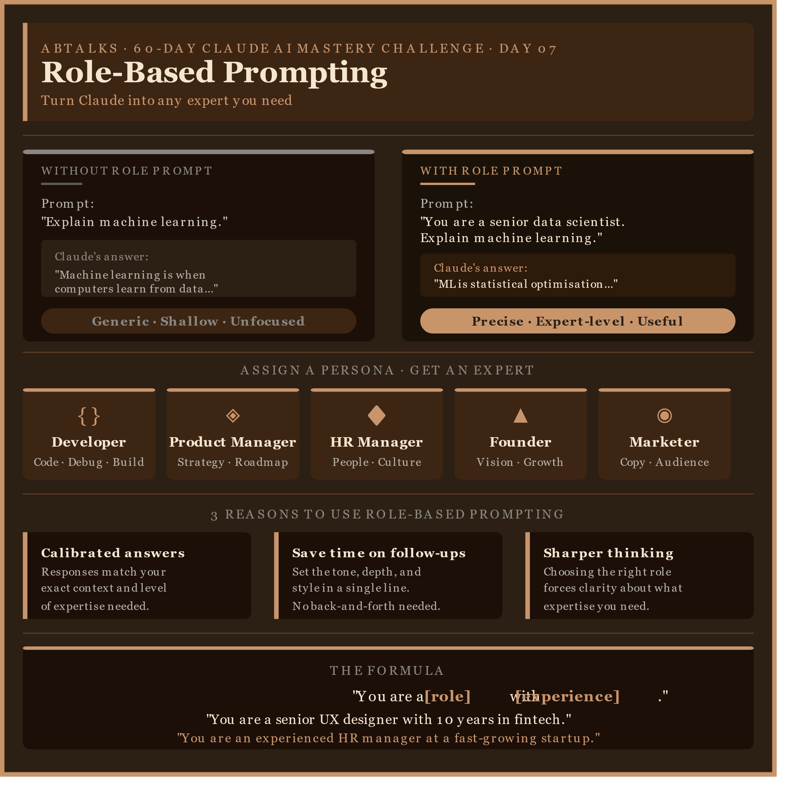
The poster is ready to save and share. A few things worth noting about the design choices:
The brown-to-dark-mahogany background with cream and warm amber text is directly pulled from Claude's color identity — it feels premium without being loud. The amber top/bottom accent bars and the left-edge color tabs on the benefit cards all use #C8956B, which is the closest you can get to Claude's signature warmth in a flat design.
The comparison section is the visual anchor — the gray-capped "without" block versus the amber-capped "with" block makes the difference immediately legible even at a glance on a LinkedIn feed.For the formula at the bottom, the most shareable thing you can leave someone with from this post is the actual template sentence, so that's what gets the final real estate.

📚 Key Learnings
- Learned the concept of Role-Based Prompting and how assigning a specific role improves AI responses.
- Understood the importance of giving AI context, expertise, and perspective through roles.
- Compared generic responses with expert-level responses generated using role prompts.
- Explored different personas such as Developer, Product Manager, HR Manager, Founder, and Marketer.
- Used learning resources provided during the challenge along with GeeksforGeeks articles to strengthen my understanding of prompt engineering concepts.
- Realized that well-defined roles help AI generate more accurate, relevant, and actionable outputs.

🛠️ What I Worked On
- Studied Role-Based Prompting fundamentals.
- Practiced creating prompts with different professional roles.
- Analyzed how role assignment affects response quality.
- Created a LinkedIn-ready visual explaining the concept.
- Referenced challenge materials and GeeksforGeeks resources for additional learning.

🎯 Main Takeaway
The clearer the role assigned to AI, the more focused, relevant, and expert-like the response becomes.
Screenshots:
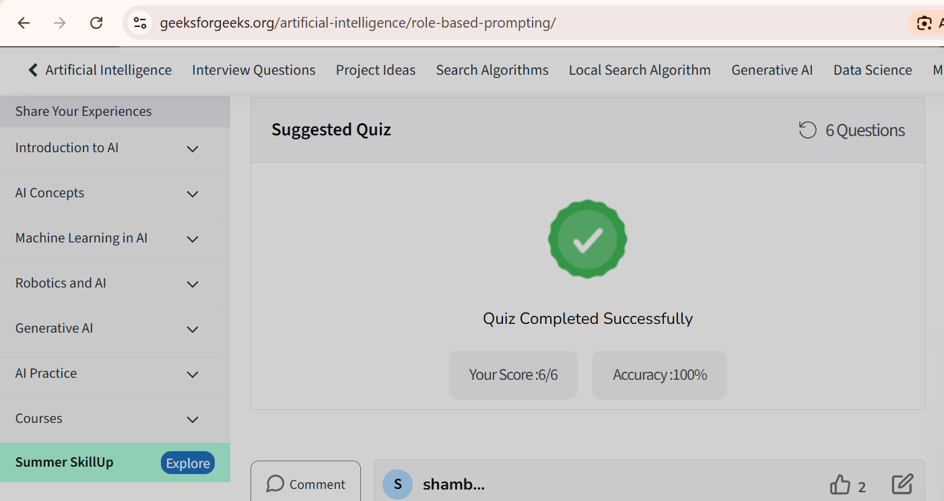

Claude Usage Counter Screenshot:
